**Business Requirements Document for Find Your Recipe**

Matthew Sloyan – G00348036

Find Your Recipe - Xamarin Application

**Home Page:**

1. The user will select a tabbed page title and the specific page will load.
2. On Android the user will swipe the bottom of the screen to change pages.
3. The user will tap/click a graphic button and the correct page will display.
4. Favourite recipes will be displayed if saved.
   1. If no favourites have been added five template recipes will be loaded in the favourites scroll view.
5. A selection of random recipes will be displayed in the second horizontal scroll view.

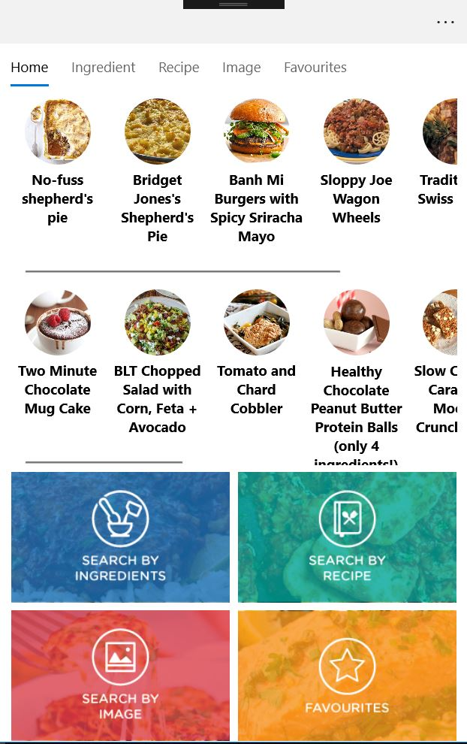

**Search by Ingredients Page:**

1. A user will search for recipes using ingredients.
   1. Each ingredient will be a string input.
2. If “ADD” button is selected a new input box will be added.
3. If “DEL” button is selected an input box will be removed from the bottom.

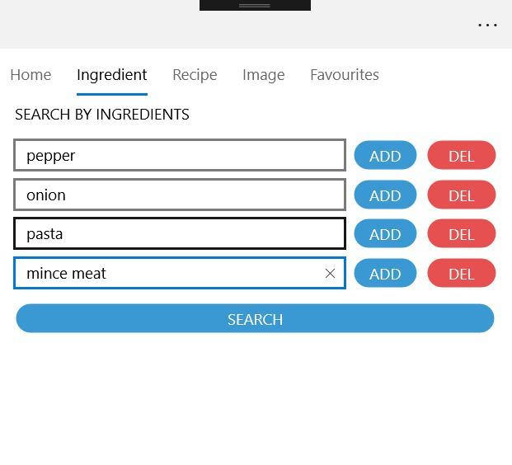

**Search by Recipe Page:**

1. A user will search for a specific recipe.
   1. Each input will be a string input.
   2. To search, recipe name must be entered.
   3. A user can enter one single diet input.
   4. A user can enter multiple ingredients to excluded (Must be comma separated).
   5. A user can enter multiple intolerances to excluded (Must be comma separated).

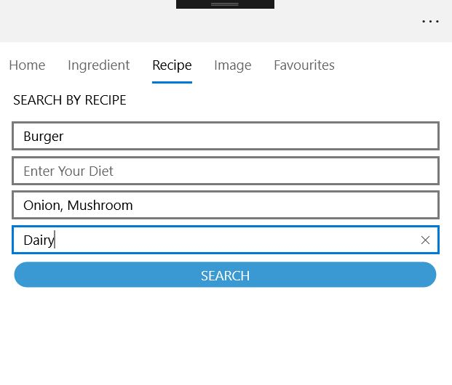

**Search by Image Page:**

1. A user will select “Take Picture” which will load device specific camera.
2. A user will select a number of ingredients from the picker selection.
3. A user will search for a recipe using an image.
   1. The image will be scanned, and objects found will be returned.
   2. A page with recipe results will be displayed based on objects found.

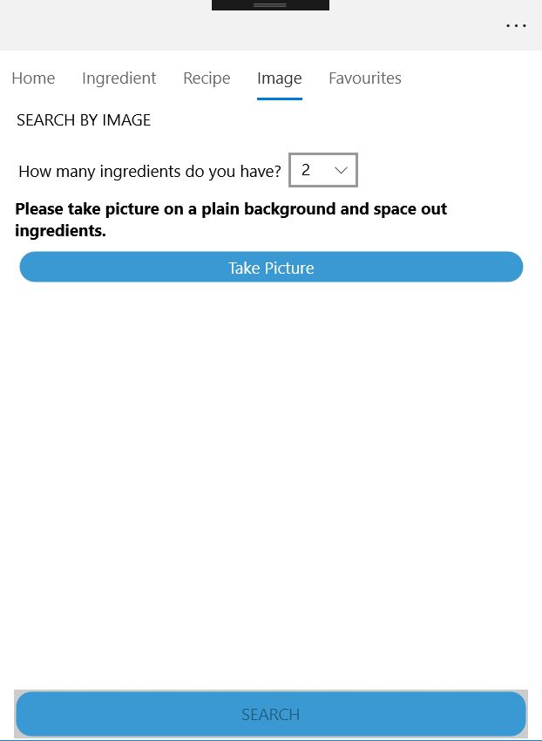

**Favourites Page:**

1. A list of user’s favourite recipes will display if saved.
2. The user will be able to view more information by selecting recipe.
3. The user will be able to remove recipe by selecting “DEL”
   1. Sound will play if turned on.

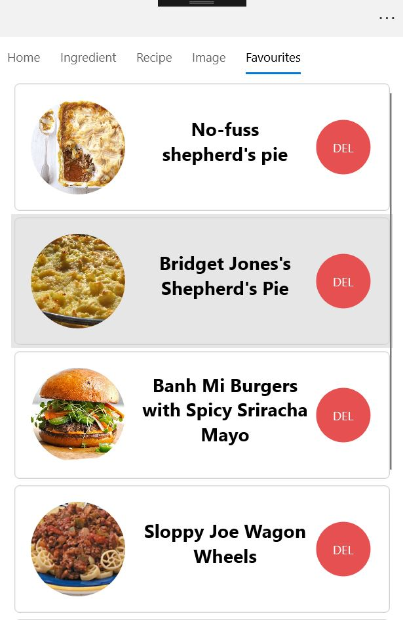

**Display Recipe List Pages:**

1. A list of recipes will display based on query.
2. The user will be able to view more information by selecting recipe.
3. The user will be able to add recipe to favourites by selecting “ADD”
   1. Success alert will display if added.

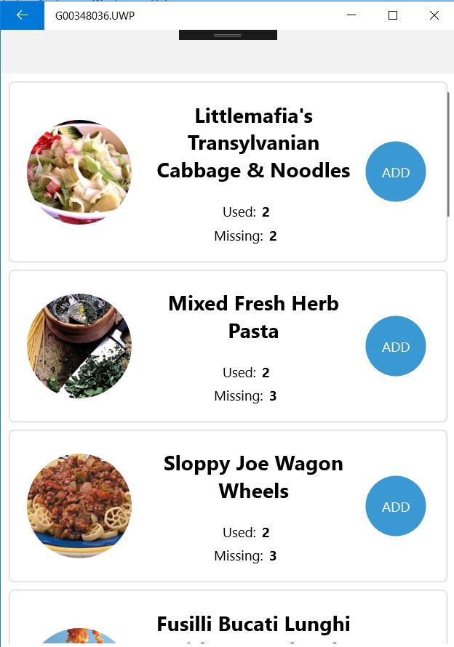

**Recipe Information Page:**

1. Recipe information will be displayed once loaded.

